**Practical Assignment no 6**

**Implement Bully and Ring algorithm for leader election**

**Bully Election Algorithms :**

import java.io.InputStream; import java.io.PrintStream; import java.util.Scanner;

public class Bully

{

static boolean[] state = new boolean[5]; int coordinator;

public static void up(int up)//4

{

if (state[up - 1])// 0 1 2 3 4

{

System.out.println("process" + up + "is already up");

}

else

{ int i;

Bully.state[up - 1] = true;

System.out.println("process " + up + "held election"); for (i = up; i < 5; ++i)

{

System.out.println("election message sent from process" + up + "to process" + (i + 1));

}

for (i = up + 1; i <= 5; ++i)

{

if (!state[i - 1]) continue;

System.out.println("alive message send from process" + i + "to process" + up); break;

}

}

}

public static void down(int down)

{

if (!state[down - 1])

{

System.out.println("process " + down + "is already dowm.");

}

else

{

Bully.state[down - 1] = false;

}

}

public static void mess(int mess)

{

if (state[mess - 1])

{ if (state[4])

{

System.out.println("0K");

} else if (!state[4])

{ int i;

System.out.println("process" + mess + "election"); for (i = mess; i < 5; ++i)

{

System.out.println("election send from process" + mess + "to process " + (i + 1));

}

for (i = 5; i >= mess; --i)

{

if (!state[i - 1]) continue;

System.out.println("Coordinator message send from process" + i + "to all"); break;

}

}

}

else

{

System.out.println("Prccess" + mess + "is down");

}

}

public static void main(String[] args)

{

int choice;

Scanner sc = new Scanner(System.in); for (int i = 0; i < 5; ++i)

{

Bully.state[i] = true;

}

System.out.println("5 active process are:");

System.out.println("Process up = p1 p2 p3 p4 p5"); System.out.println("Process 5 is coordinator"); do

{

System.out.println(".........");

System.out.println("1 up a process.");

System.out.println("2.down a process");

System.out.println("3 send a message"); System.out.println("4.Exit"); choice = sc.nextInt(); switch (choice)

{

case 1:

{

System.out.println("bring proces up"); int up = sc.nextInt(); if (up == 5)

{

System.out.println("process 5 is co-ordinator"); Bully.state[4] = true; break;

}

Bully.up(up); break;

}

case 2:

{

System.out.println("bring down any process."); int down = sc.nextInt(); Bully.down(down); break;

}

case 3:

{

System.out.println("which process will send message"); int mess = sc.nextInt(); Bully.mess(mess);

}

}

} while (choice != 4);

}

}

**Output:**

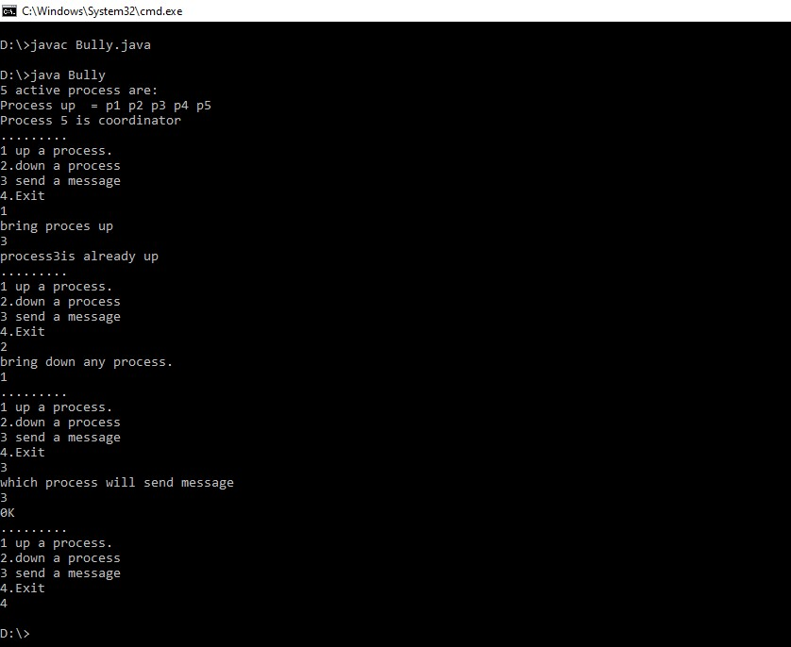

**Ring Election Algorithm :**

import java.util.Scanner;

public class Ring

{

public static void main(String[] args)

{

// TODO Auto-generated method stub

int temp, i, j; char str[] = new char[10]; Rr proc[] = new Rr[10];

// object initialisation for (i = 0; i < proc.length; i++) proc[i] = new Rr();

// scanner used for getting input from console

Scanner in = new Scanner(System.in); System.out.println("Enter the number of process : "); int num = in.nextInt();

// getting input from users

for (i = 0; i < num; i++)

{

proc[i].index = i;

System.out.println("Enter the id of process : "); proc[i].id = in.nextInt(); proc[i].state = "active"; proc[i].f = 0;

}

// sorting the processes from on the basis of id for (i = 0; i < num - 1; i++)

{

for (j = 0; j < num - 1; j++)

{

if (proc[j].id > proc[j + 1].id)

{

temp = proc[j].id; proc[j].id = proc[j + 1].id; proc[j + 1].id = temp;

}

}

}

for (i = 0; i < num; i++)

{

System.out.print(" [" + i + "]" + " " + proc[i].id);

}

int init; int ch; int temp1; int temp2; int ch1; int arr[] = new int[10]; proc[num - 1].state = "inactive";

System.out.println("\n process " + proc[num - 1].id + "select as co-ordinator");

while (true)

{

System.out.println("\n 1.election 2.quit "); ch = in.nextInt();

for (i = 0; i < num; i++)

{

proc[i].f = 0;

}

switch (ch)

{

case 1:

System.out.println("\n Enter the Process number who initialsied

election : ");

init = in.nextInt(); temp2 = init; temp1 = init + 1; i = 0;

while (temp2 != temp1)

{

if ("active".equals(proc[temp1].state) && proc[temp1].f ==

0)

{

System.out.println("\nProcess " + proc[init].id + "

send message to " + proc[temp1].id); proc[temp1].f = 1; init = temp1; arr[i] = proc[temp1].id;

i++;

}

if (temp1 == num)

{

temp1 = 0;

}

else

{

temp1++;

}

}

System.out.println("\nProcess " + proc[init].id + " send message to

" + proc[temp1].id); arr[i] = proc[temp1].id; i++;

int max = -1;

// finding maximum for co-ordinator selection

for (j = 0; j < i; j++)

{

if (max < arr[j])

{

max = arr[j];

}

}

// co-ordinator is found then printing on console

System.out.println("\n process " + max + "select as co-ordinator");

for (i = 0; i < num; i++)

{

if (proc[i].id == max)

{

proc[i].state = "inactive";

}

}

break;

case 2:

System.out.println("Program terminated ..."); return ; default:

System.out.println("\n invalid response \n");

break;

}

}

}

}

class Rr

{

public int index; // to store the index of process

|  |  |
| --- | --- |
| public int id; public int f; | // to store id/name of process |
| String state; | // indiactes whether active or inactive state of node |

}

**Output:**

